**CMSC 204**

**ASSIGNMENT 3 : DOCUMENT**

Submitted by: Rabindra Raj Suwal

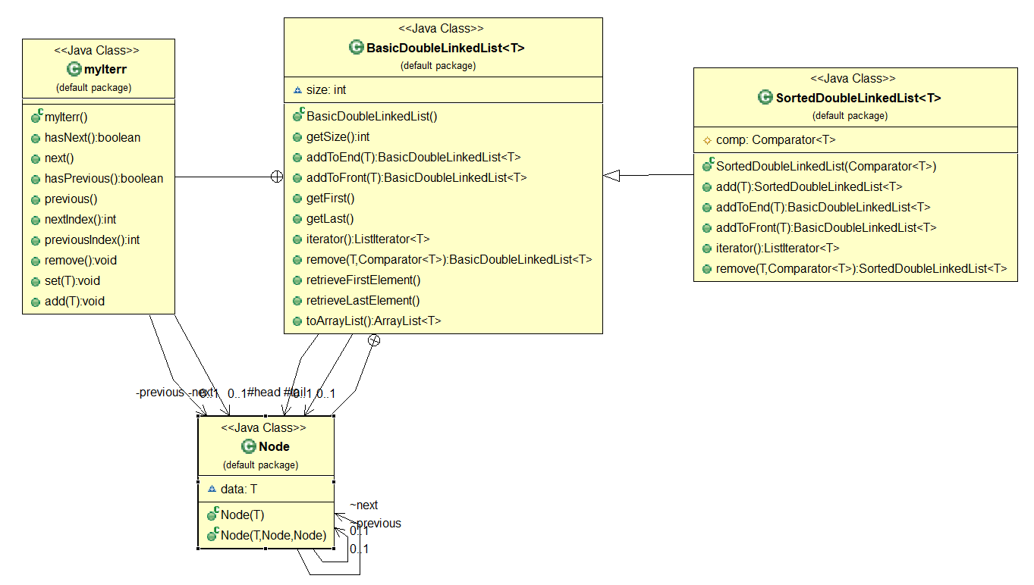**FINAL DESIGN:**

**Lesson Learned:**

In this assignment, we were required to write codes for a generic double singly-linked list and a generic sorted double singly-linked list. We were provided the GUI driver and the Junit test cases. The GUI and the Junit tests helped a lot in visualizing the linked lists. Some new concepts I learned from this project are Linked Lists, Iterators and Comparators.

This project was very confusing as it had so many methods and an inner node class. I had problems with keeping track of what I was doing because of the same reason. I went through the provided test cases and the GUI to know if I was on the right track. The way exceptions were handled in this project was also new to me as we had been creating separate classes for all the exceptions in our previous projects. Using Java Library Exceptions was easier and time saving.

The Javadoc provided was super helpful as always. I knew what methods to create with the help of it. Even though the whole project was confusing because of all the methods, the method itself were pretty easy and straight forward.